Two Sum

Given an array of integers nums and an integer target, return indices of the two numbers such that they add up to *target*.

You may assume that each input would have **exactly one solution**, and you may not use the same element twice.

You can return the answer in any order.

**Example 1:**

**Input:** nums = [2,7,11,15], target = 9

**Output:** [0,1]

**Explanation:** Because nums[0] + nums[1] == 9, we return [0, 1].

**Example 2:**

**Input:** nums = [3,2,4], target = 6

**Output:** [1,2]

**Example 3:**

**Input:** nums = [3,3], target = 6

**Output:** [0,1]

**Constraints:**

* 2 <= nums.length <= 104
* -109 <= nums[i] <= 109
* -109 <= target <= 109
* **Only one valid answer exists.**

Palindrome Number

Given an integer x, return true if x is palindrome integer.

An integer is a **palindrome** when it reads the same backward as forward.

* For example, 121 is a palindrome while 123 is not.

**Example 1:**

**Input:** x = 121

**Output:** true

**Explanation:** 121 reads as 121 from left to right and from right to left.

**Example 2:**

**Input:** x = -121

**Output:** false

**Explanation:** From left to right, it reads -121. From right to left, it becomes 121-. Therefore it is not a palindrome.

**Example 3:**

**Input:** x = 10

**Output:** false

**Explanation:** Reads 01 from right to left. Therefore it is not a palindrome.

**Constraints:**

* -231 <= x <= 231 - 1

Add two numbers

You are given two **non-empty** array representing two non-negative integers. The digits are stored in **reverse order**, and each of their nodes contains a single digit. Add the two numbers and return the sum as a array.

You may assume the two numbers do not contain any leading zero, except the number 0 itself.

**Example 1:**

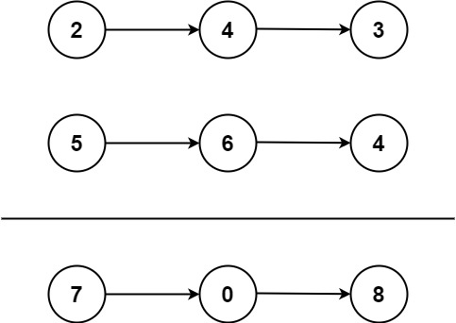

**Input:** l1 = [2,4,3], l2 = [5,6,4]

**Output:** [7,0,8]

**Explanation:** 342 + 465 = 807.

**Example 2:**

**Input:** l1 = [0], l2 = [0]

**Output:** [0]

**Example 3:**

**Input:** l1 = [9,9,9,9,9,9,9], l2 = [9,9,9,9]

**Output:** [8,9,9,9,0,0,0,1]

**Constraints:**

* The number of nodes in each array list is in the range [1, 100].
* 0 <= Node.val <= 9
* It is guaranteed that the list represents a number that does not have leading zeros.